Samuel Bernheim (bernheim@brandeis.edu) 2016-3-9

Problem 3.12

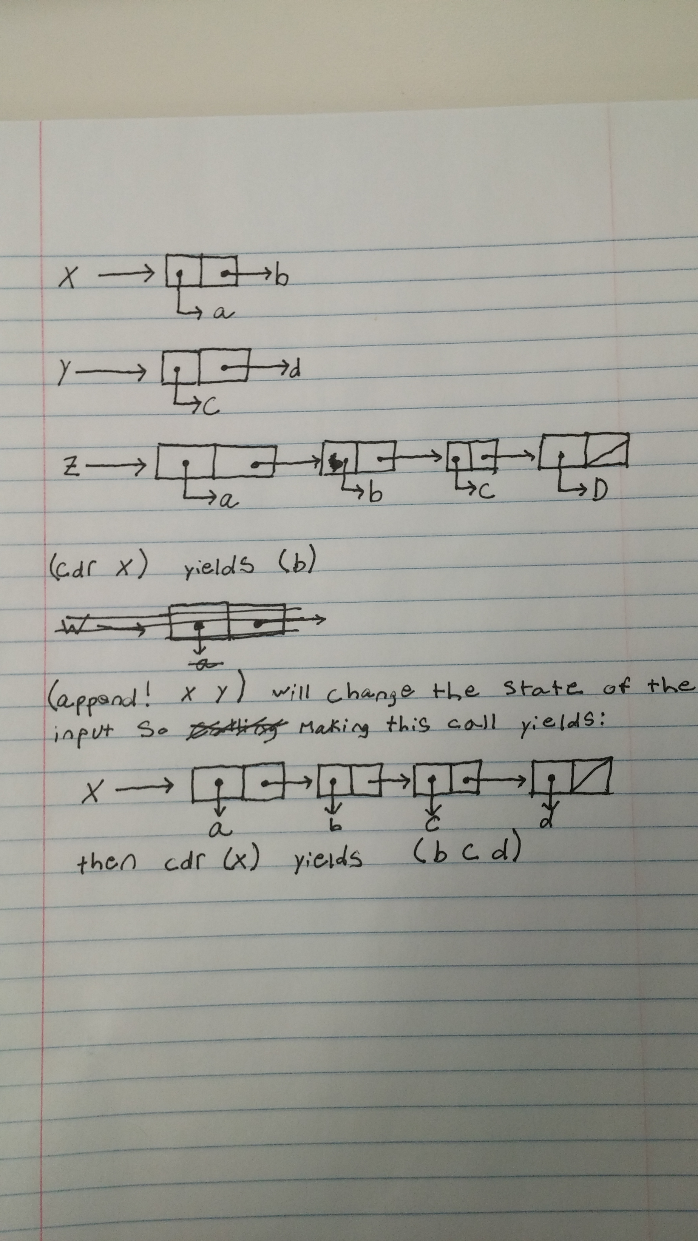

Problem 3.14

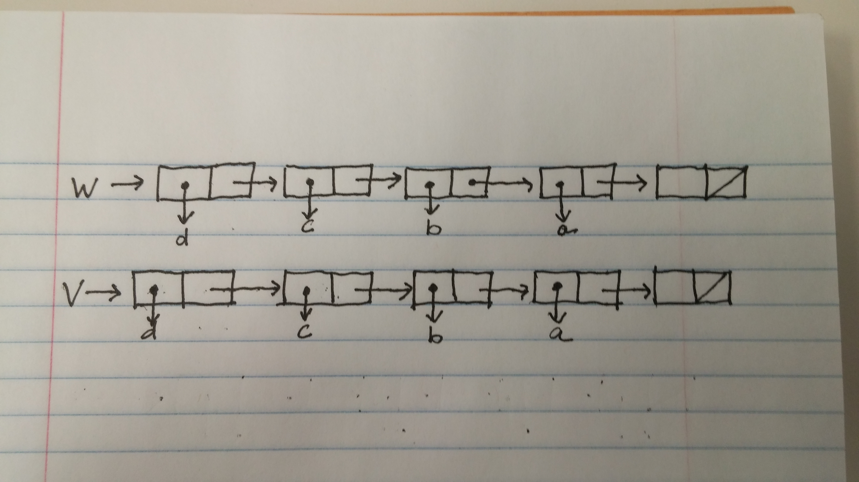

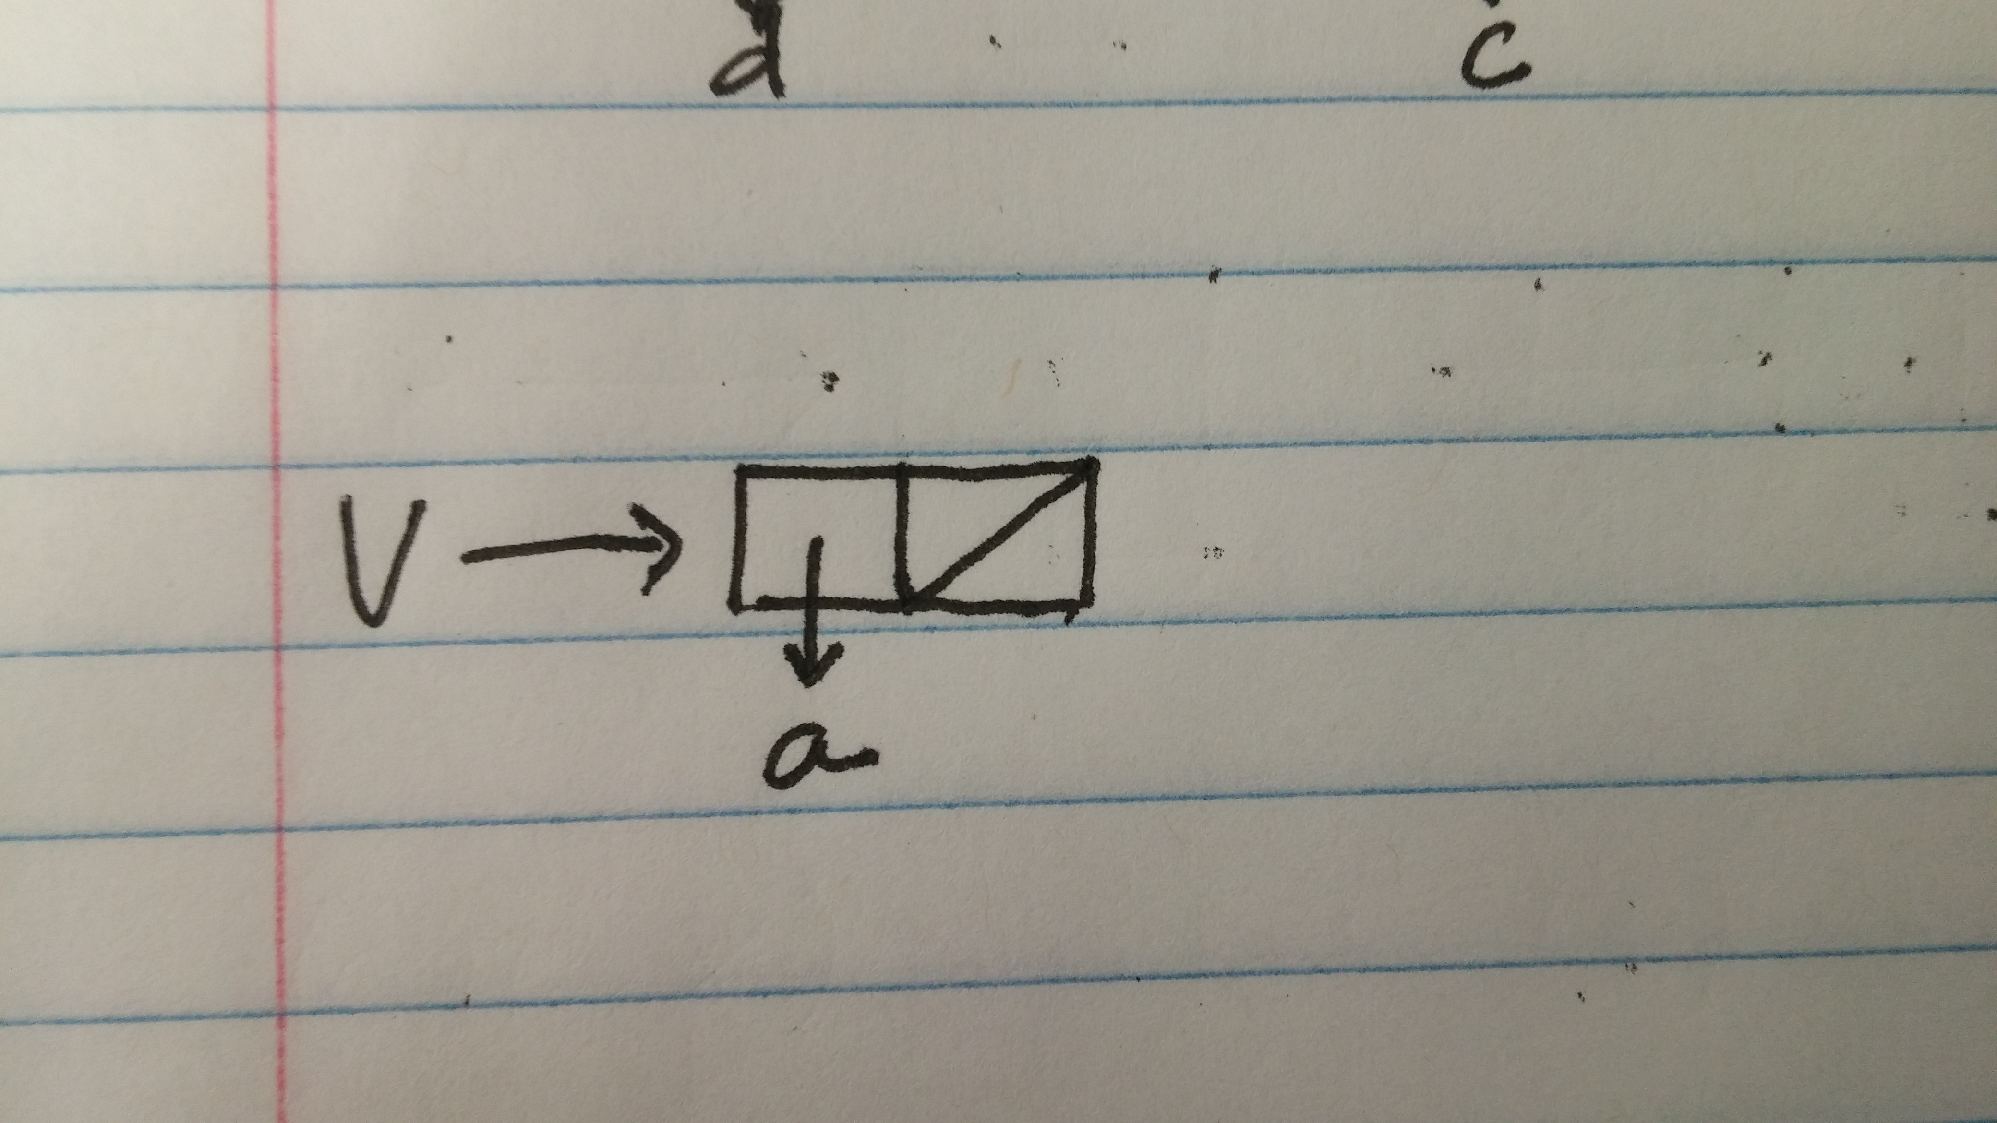

Printing v would result in (a). Printing w would result in (d c b a).

Stable Marriage

Question 1

For the couple? procedure I got the two people person1 and person2 are engaged to and checked if person1 was the same as the person, person2’s partner and if person2 was the same as person1’s partner.

For the currently-unengaged? procedure I used a lambda expression which takes an additional list as a parameter and then check to see if the first person in the list-of-people was engaged or not. Based on this I would make the appropriate recursive call.

For the send? procedure I first would check if the list-of-people was empty. If so then true is returned. Otherwise message is called on the first thing in the list and then send is called on the cdr of the list.

For the i-like-more? procedure I began by first getting the corresponding index of where each of the two people are for the person. Then I figure out which one is smaller and return the corresponding person.

Question 2

To complete the i-love-you procedure I handled the three possible cases. If the person being proposed to is unengaged, then that person accepts and the proposee’s current intended is set to the proposer and the phrase i-love-you-too is returned. Otherwise the propose is engaged. In this case I first determine if the propose likes the proposer more than they like the person to whom they are currently engaged. If they do, then the phrase buzz-off-you-creep is returned. Otherwise i-changed-my-mind is called on the proposee’s current-intended, the proposee’s current intended is changed to be the proposer, and i-love-you-too is returned.

Question 3

Question 4

Question 5

Question 6

Question 7